Data Movement Pipeline using

Azure Data Factory and Azure Devops

Table of Contents

- Project Statement
- Project Overview & Objectives
- Prerequisites
- Azure Resources Used
- Implementation Steps
- Verification & Output
- CI/CD Pipeline Setup
- Conclusion & Learnings

1. Project Statement:
This project involves creating a data movement pipeline using Azure Data Factory (ADF) to copy data from a simulated on-premises Azure SQL Database to Azure Synapse Analytics. Azure DevOps is used for version control and CI/CD integration of the pipeline, ensuring continuous delivery of updates.
2. Project Overview & Objectives:

2.1 Overview
The pipeline automates the process of moving structured data from an on-premises source (Azure SQL Database) to a cloud data warehouse (Azure Synapse Analytics). ADF manages data movement, while Azure DevOps ensures version control and deployment readiness.

2.2 Objectives
- Set up Azure resources to support the pipeline.
- Create a pipeline in ADF to copy data from source to sink.
- Validate data movement and ensure successful loading into Synapse.
- Integrate ADF with Azure DevOps for source control and publishing.
- Prepare CI/CD pipeline (partially implemented due to pending Microsoft access).

3. Prerequisites:
- Azure Subscription (with permissions to create ADF, Synapse, Storage, SQL DB).
- Azure DevOps Account (organization, project, repo).
- Basic Knowledge of data pipelines, Git, and Azure Portal navigation.

4. Azure Resources Used:
4.1 List of all resources:
- Resource Group: rg-hexaver-adf-synapse-dev
- Azure Data Lake Storage Gen2 (ADLS): Containers raw and curated
- Azure Synapse Analytics workspace
- Azure SQL Database (simulated on-premises source)
- Azure Data Factory
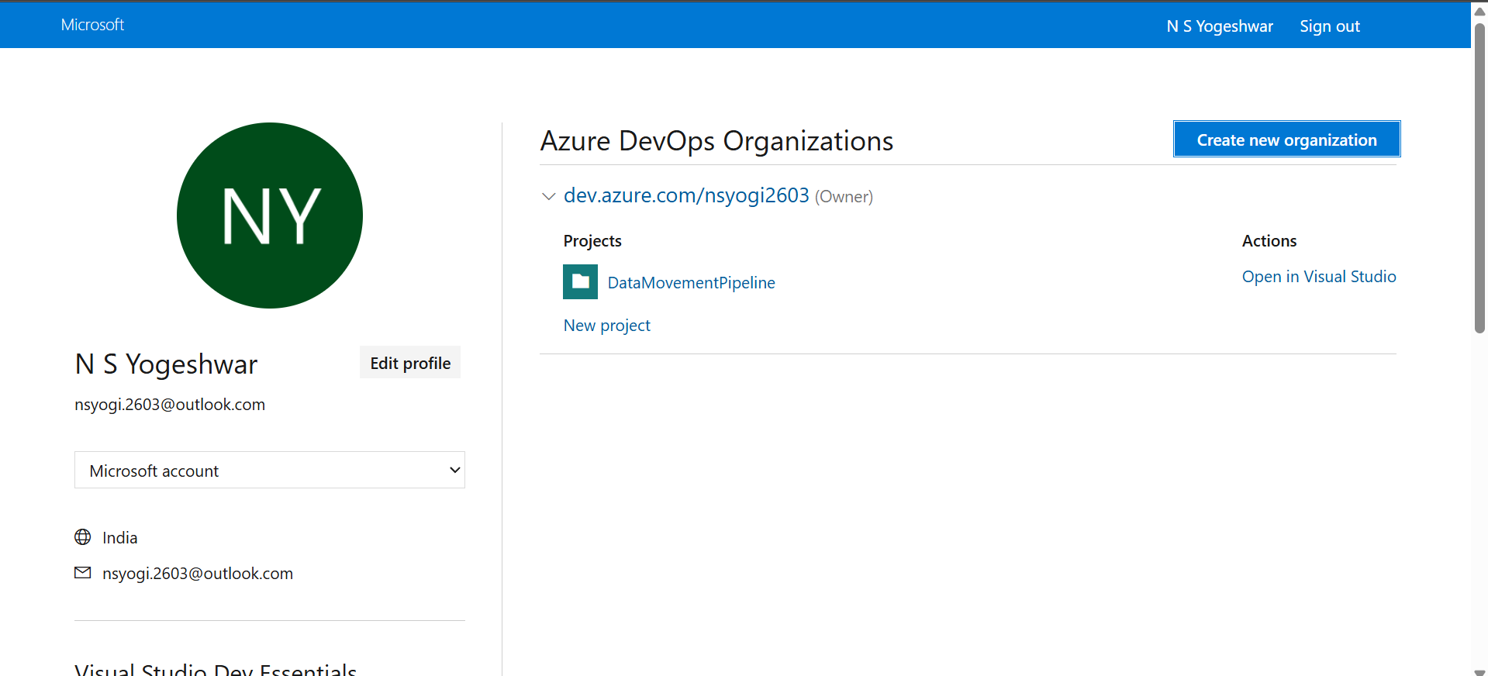
- Azure DevOps (organization, project, repo)

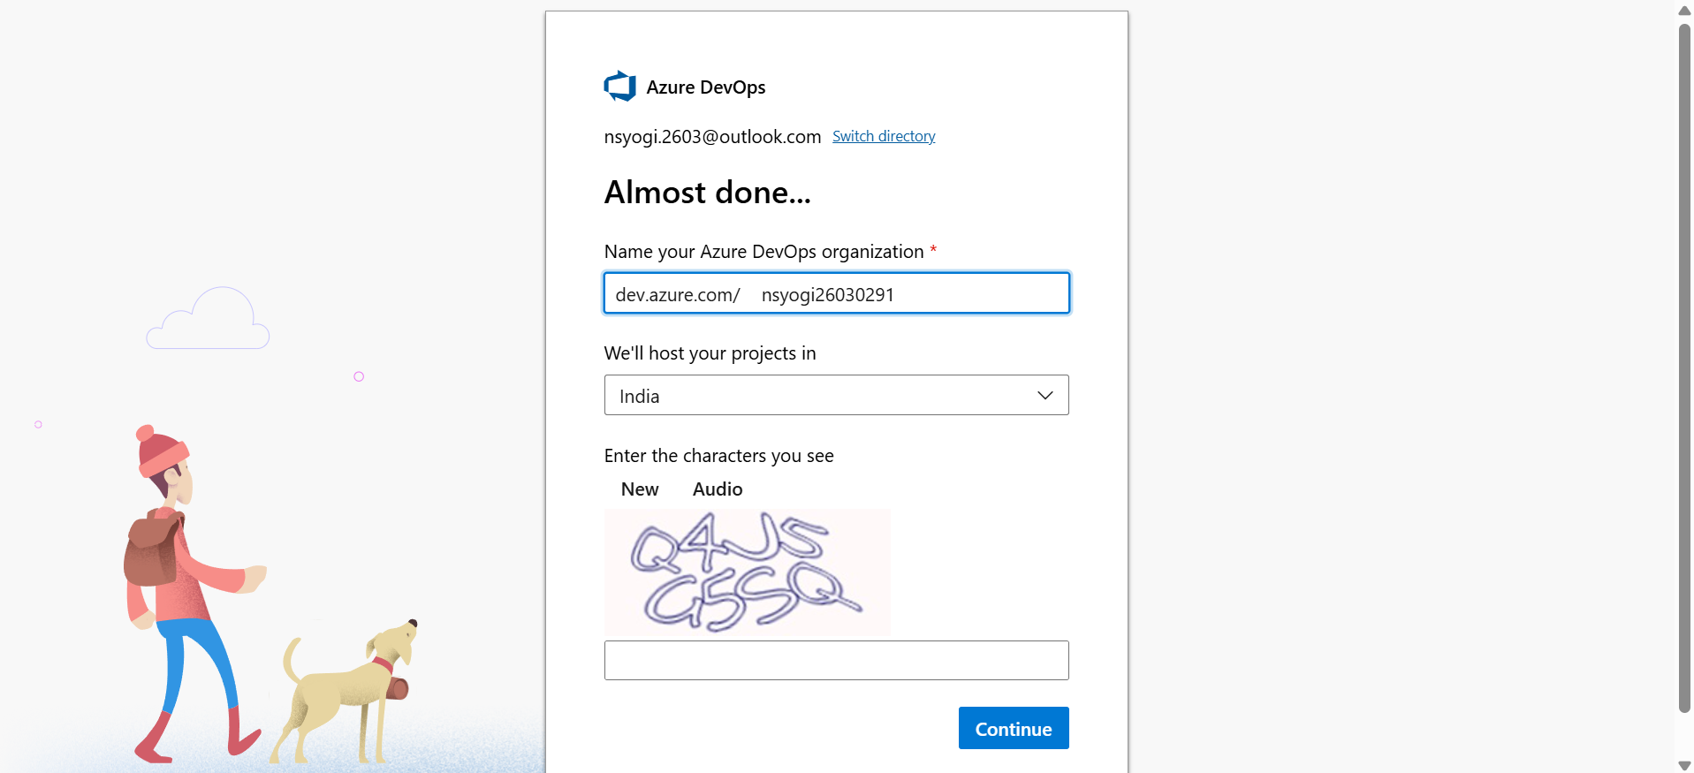

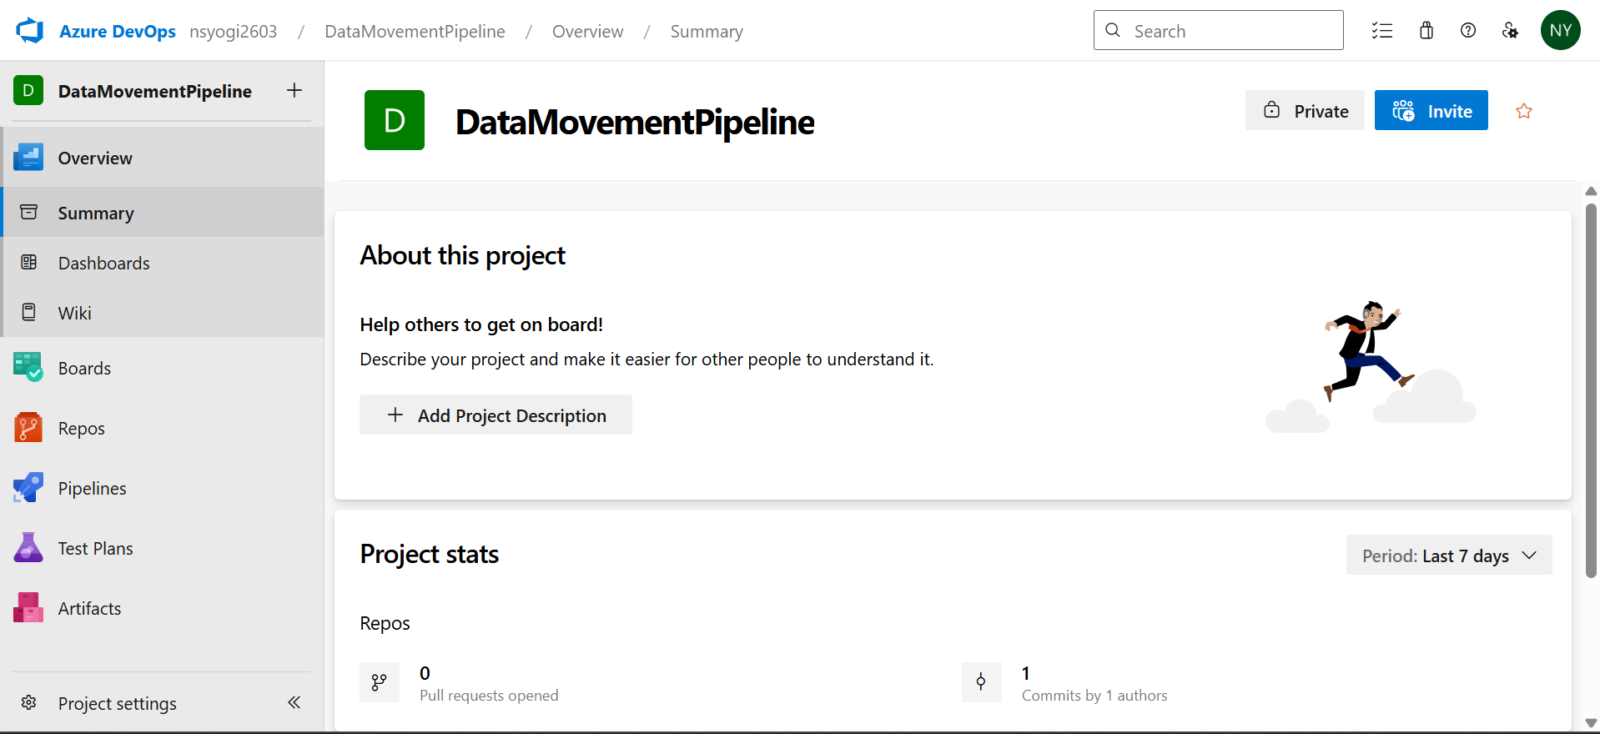

5. Implementation Steps
5.1 Creating the Resource Group
A resource group was created to logically organize all Azure resources under a single environment.
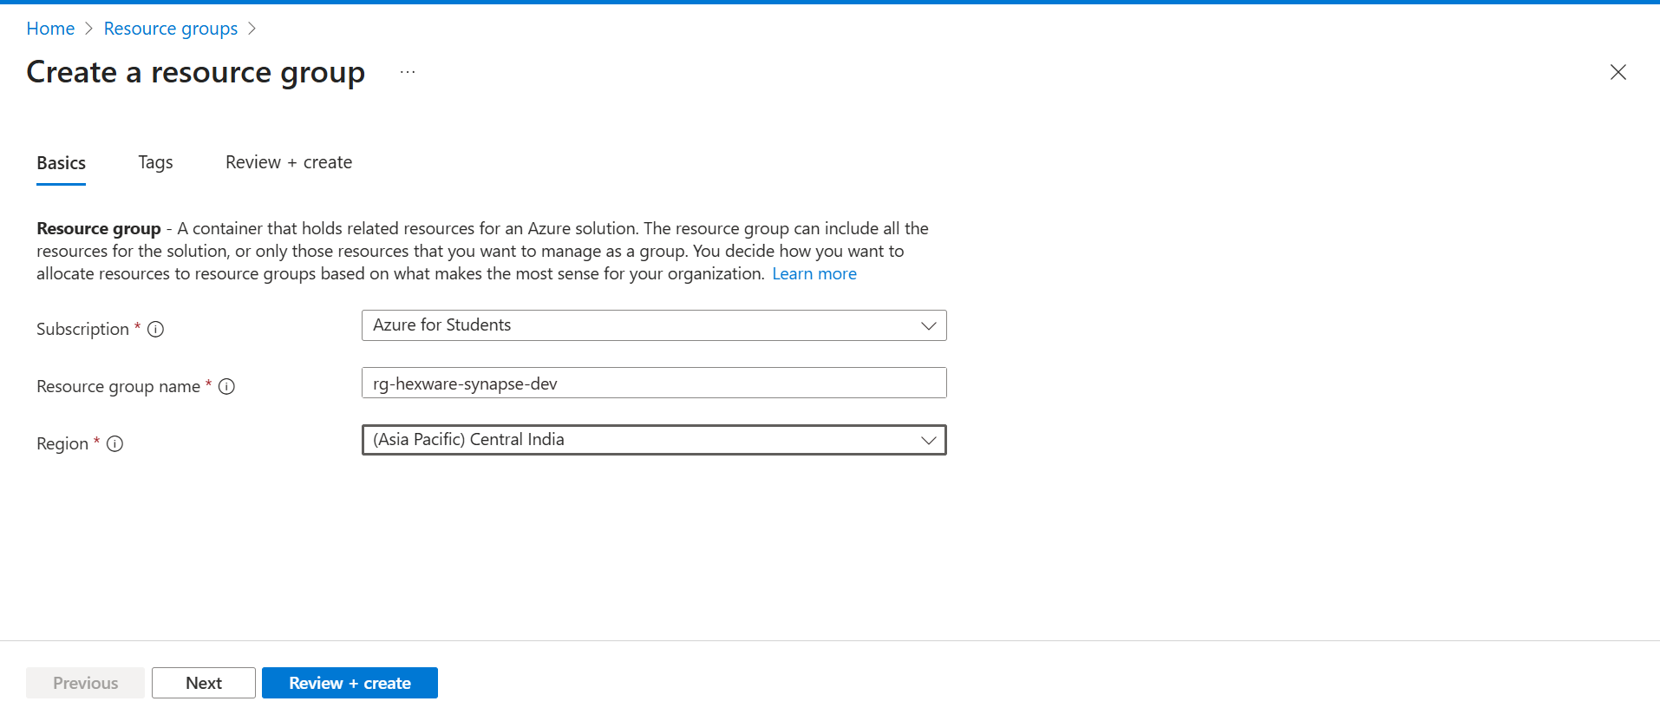

5.2 Setting up ADLS Gen2
Created ADLS Gen2 storage account with hierarchical namespace enabled, and containers raw and curated for structured data segregation.
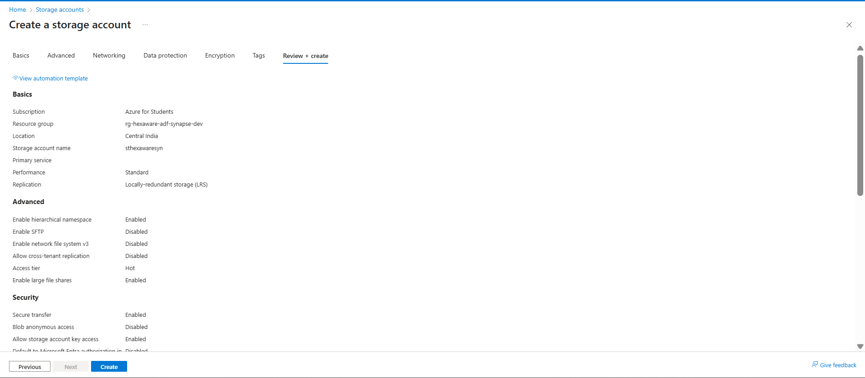

5.3 Creating Azure Synapse Analytics Workspace
Deployed Synapse workspace and verified the Data Lake link within Synapse Studio.
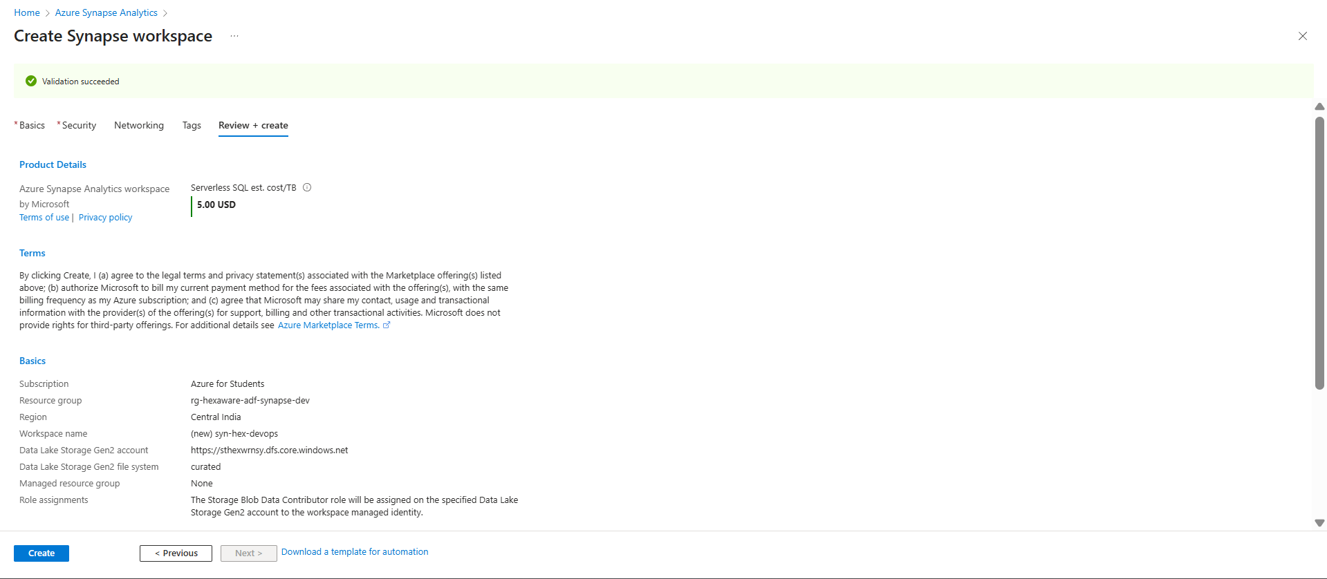

5.4 Provisioning Azure SQL Database
Created an Azure SQL Database to simulate on-prem data source. Tables and sample data were set up for pipeline use.
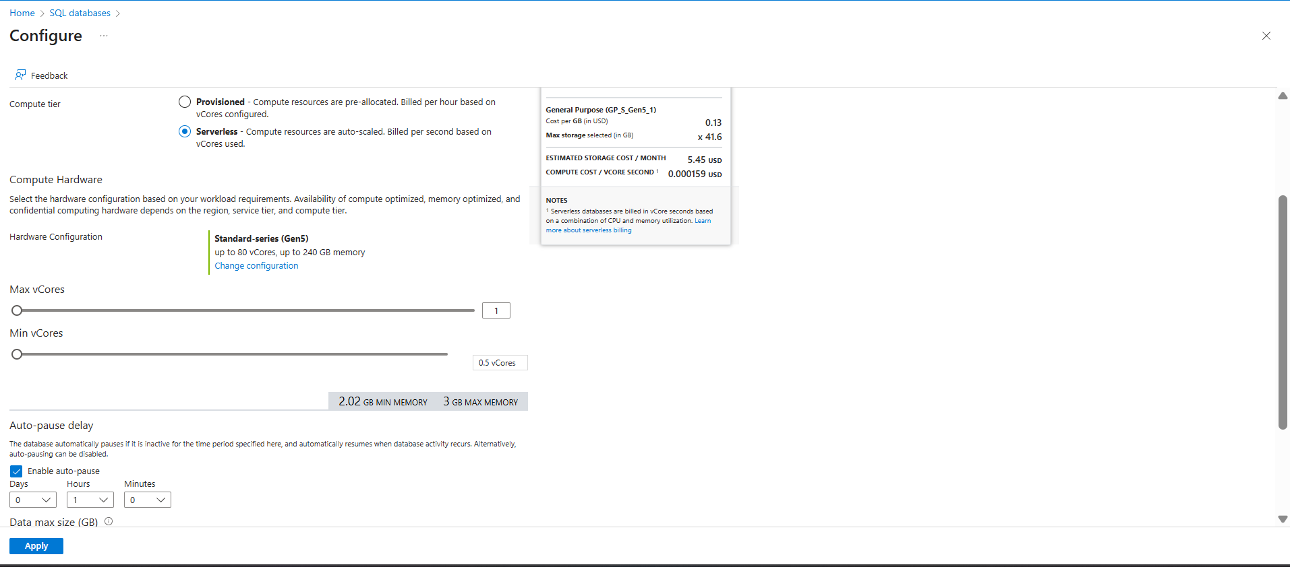
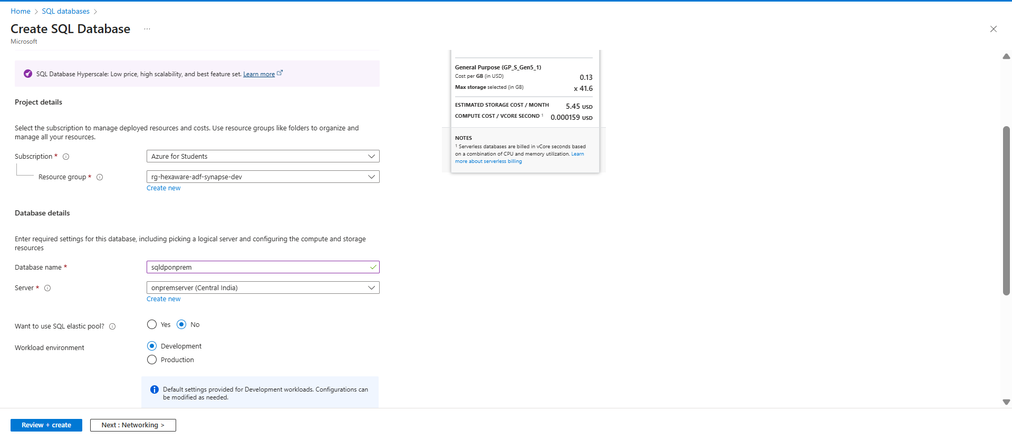

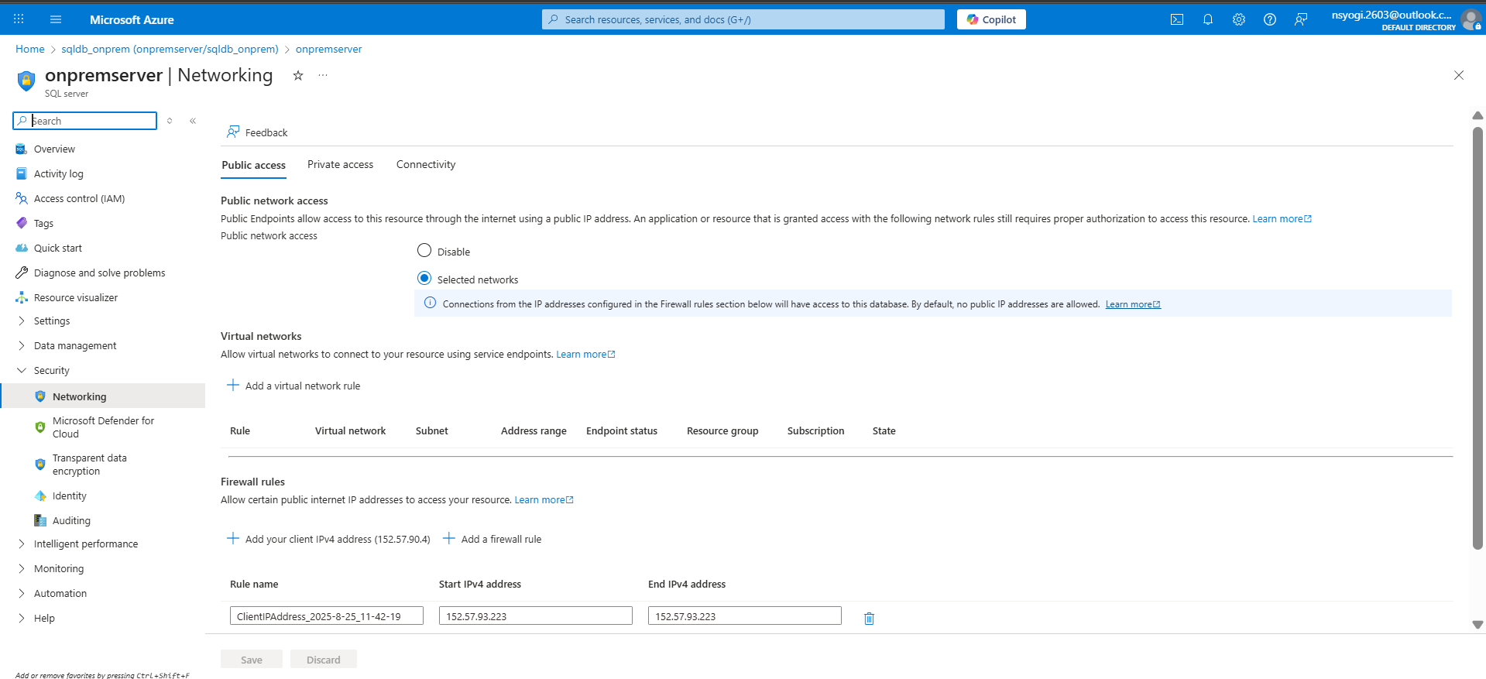

5.5 Setting up Azure Data Factory
Azure Data Factory (ADF) was created to orchestrate the data movement process.
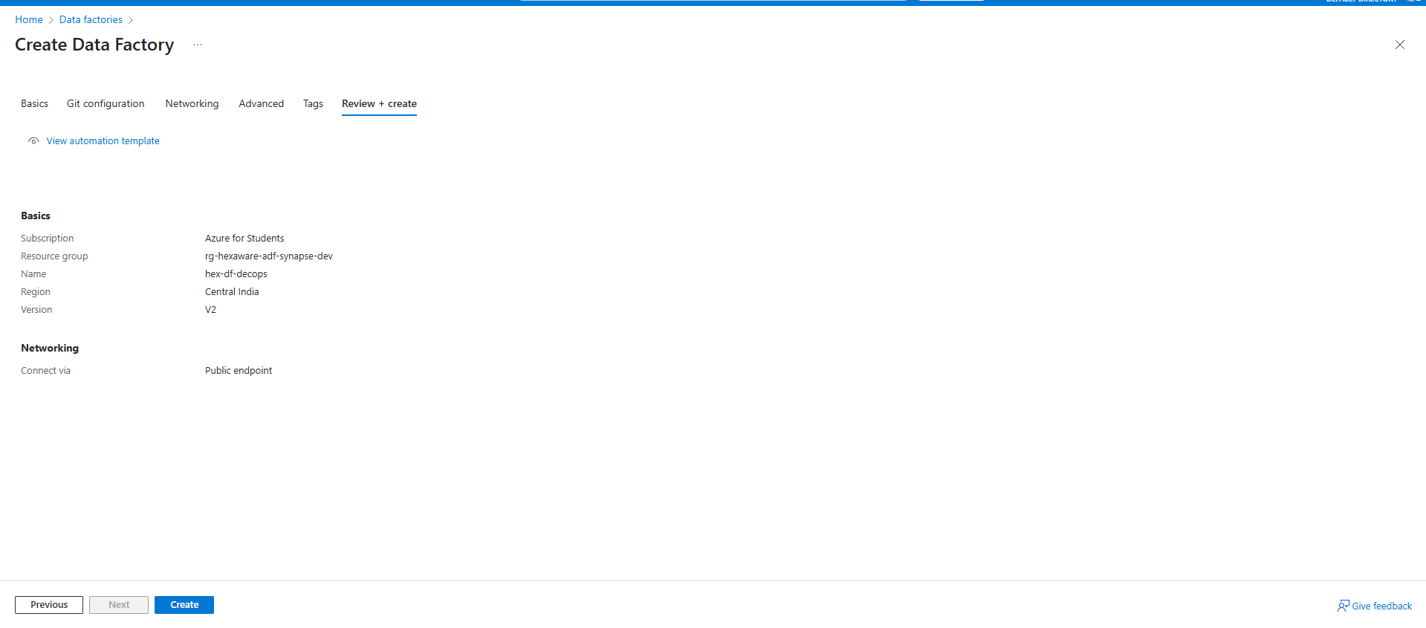
5.6 Configuring Azure DevOps for Version Control
- Azure DevOps organization, project, and repository were created.
- ADF was linked to the DevOps repo for Git-based version control.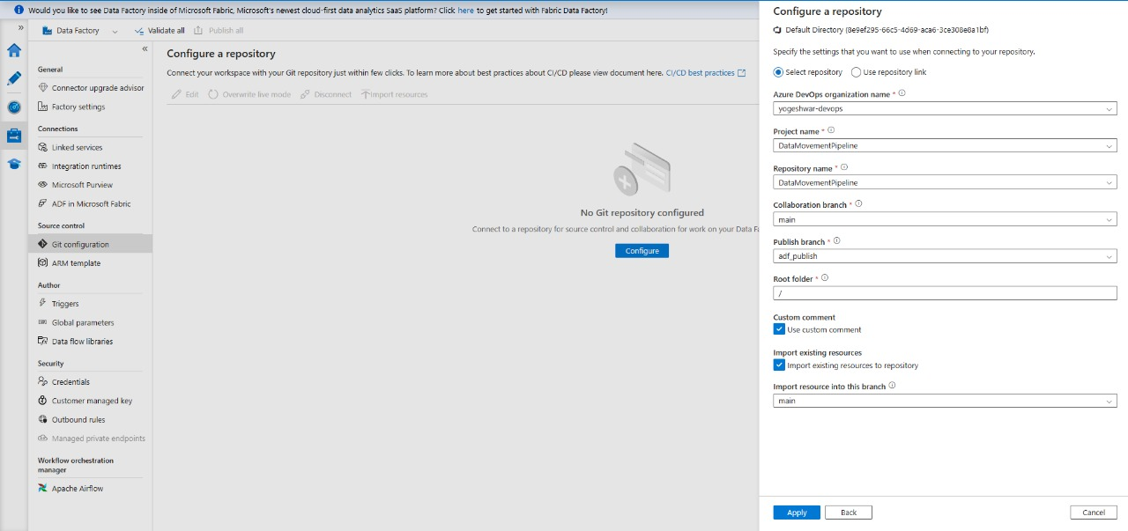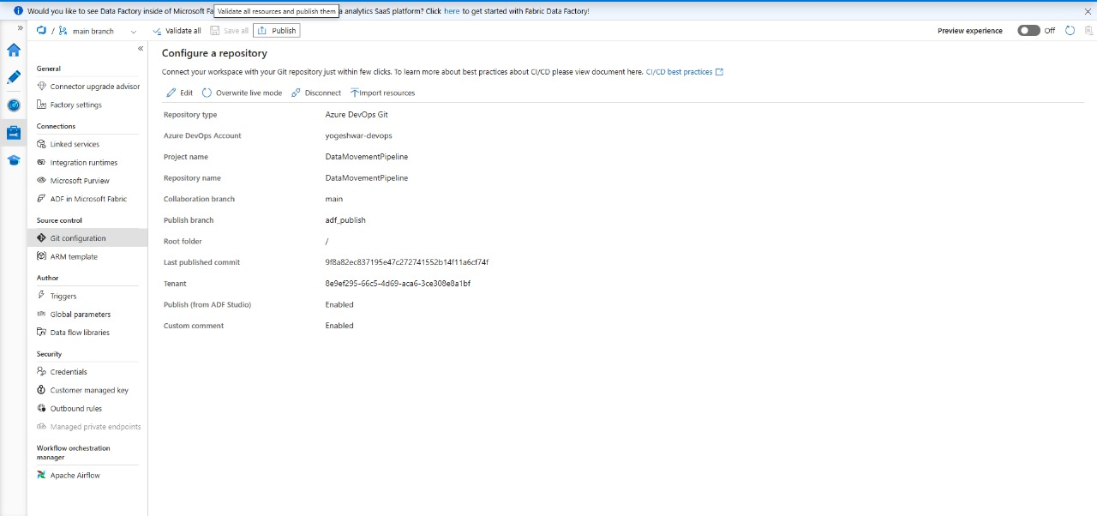
5.7 Creating Linked Services
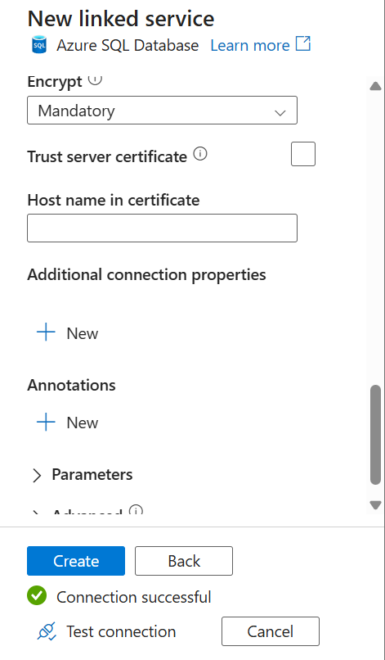
Linked services were defined in ADF to connect source (Azure SQL DB) and sink (ADLS Gen2).

5.8 Creating Datasets
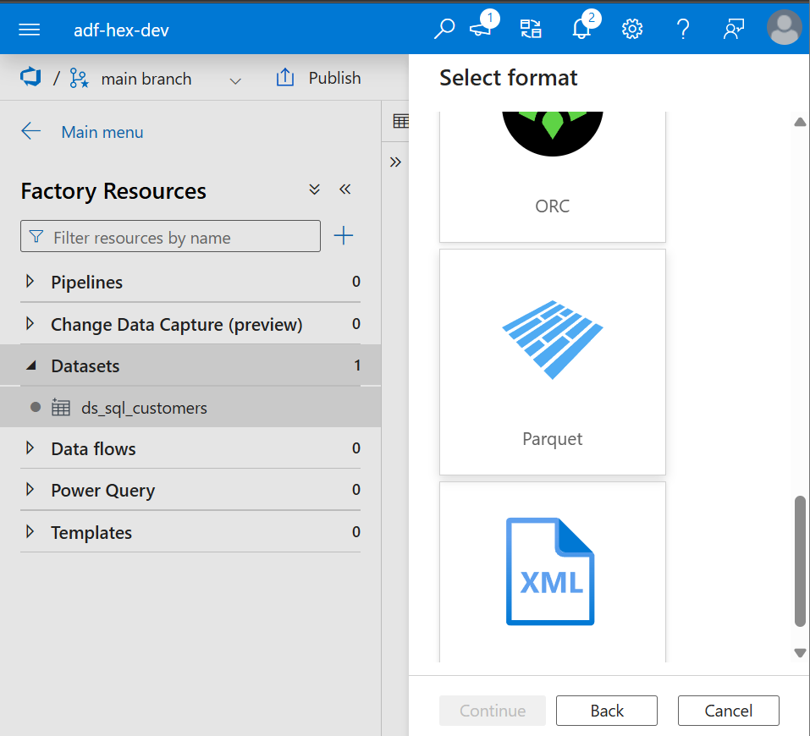
Source dataset points to SQL table; sink dataset configured to store output as Parquet in ADLS.

5.9 Building and Debugging Pipeline
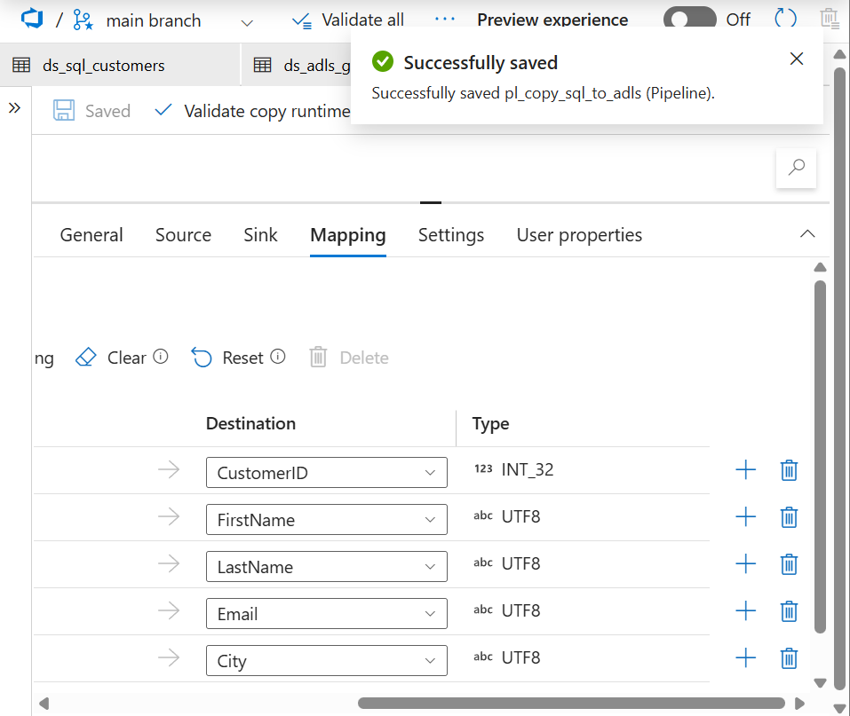
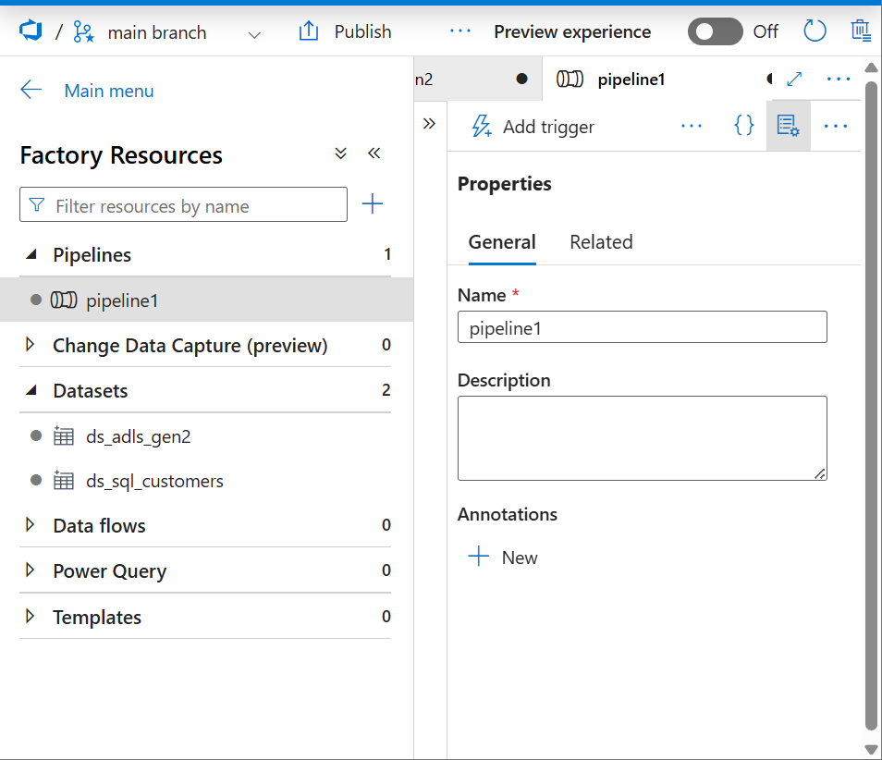
Created Copy Data activity pipeline. Configured source, sink, and mapping tabs. Debug run performed successfully.

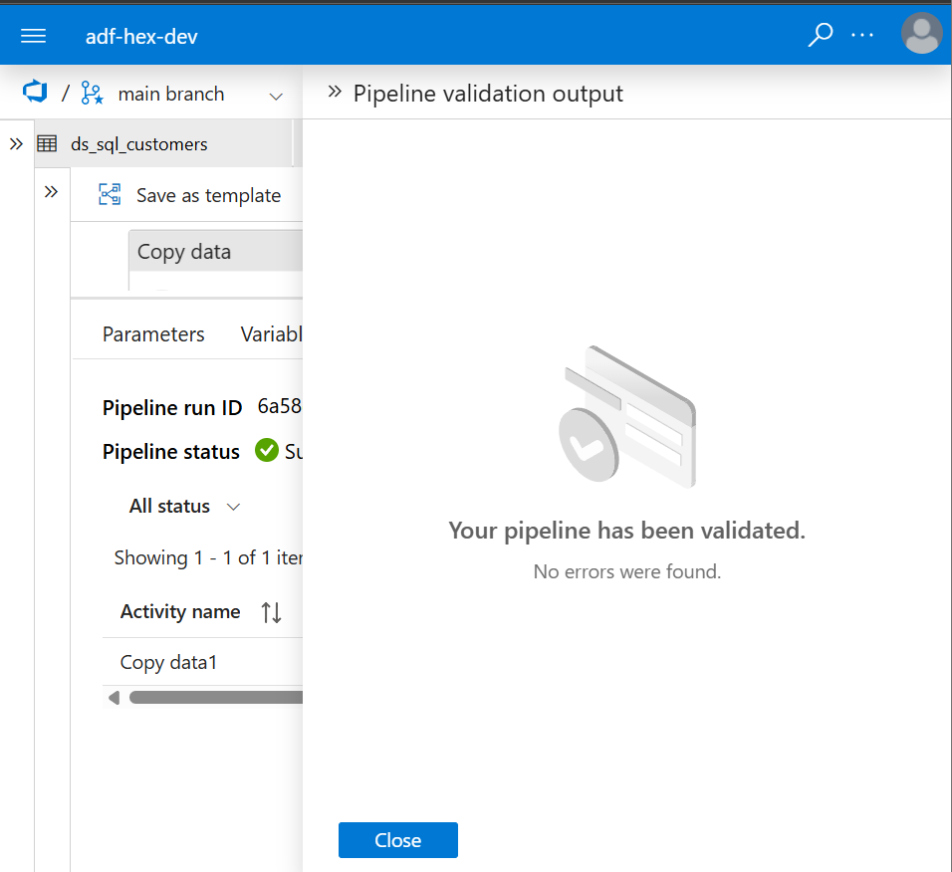

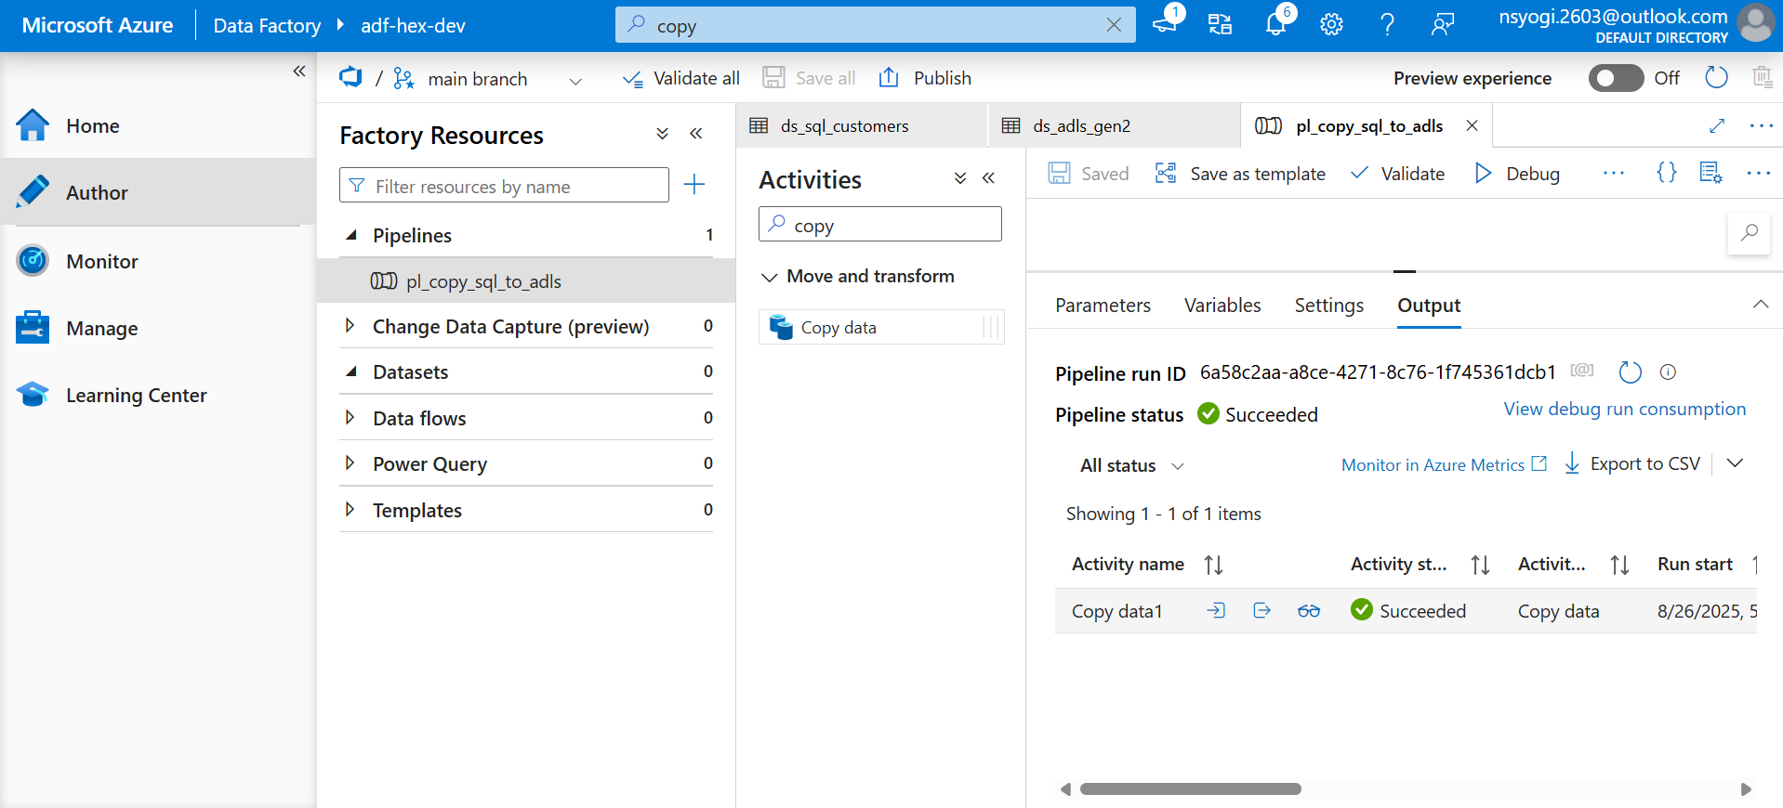

5.10 Verification via Synapse Studio
Verified copied data using OPENROWSET query in Synapse Studio.
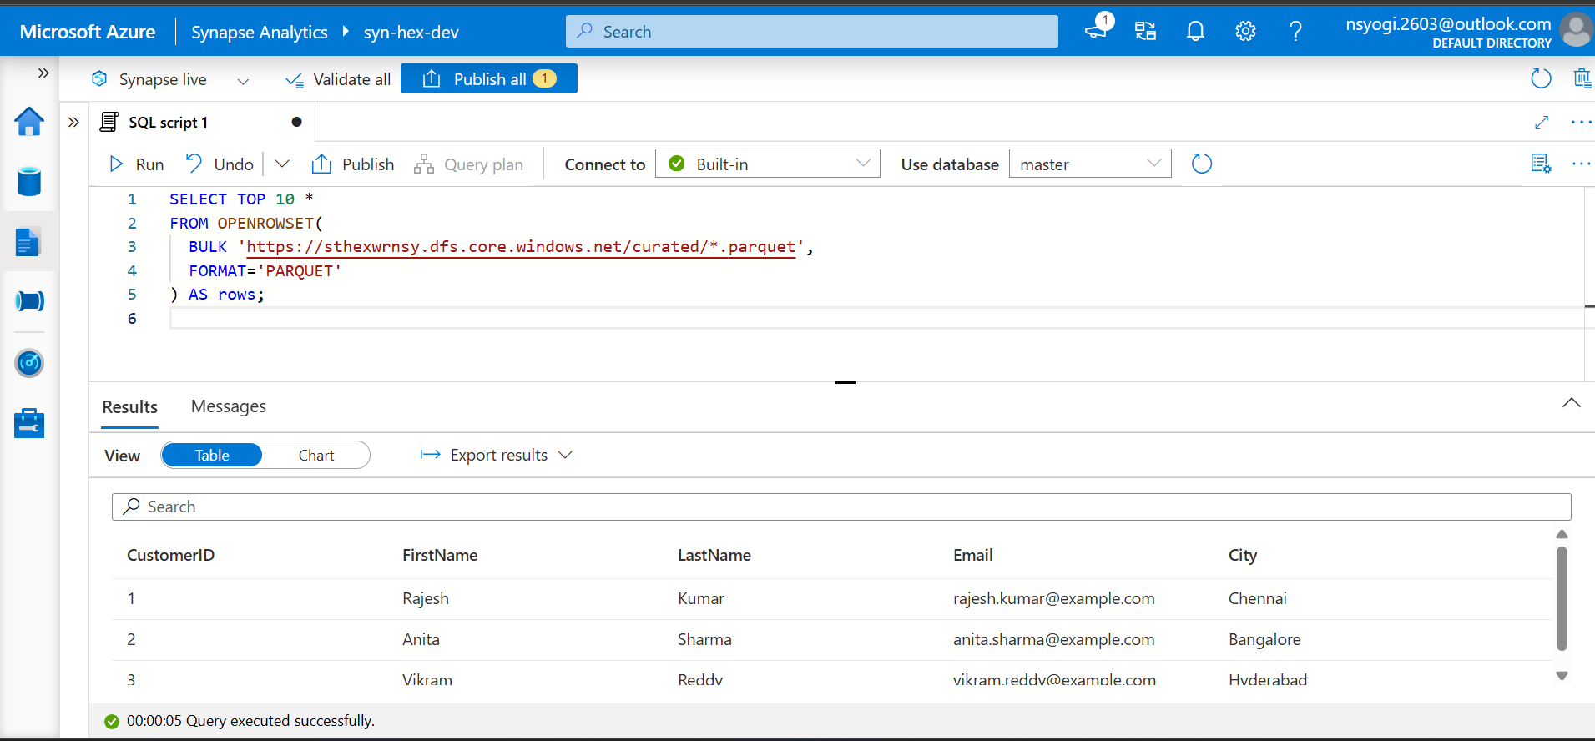
6. Verification & Output
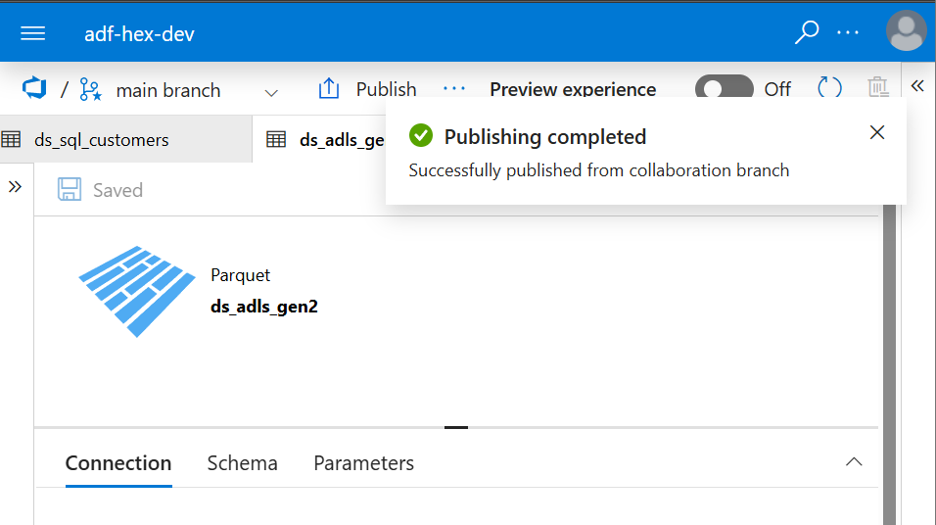
Pipeline execution succeeded, and output data was validated in Synapse. The ADF publish process stored artifacts in DevOps repository under adf_publish folder.

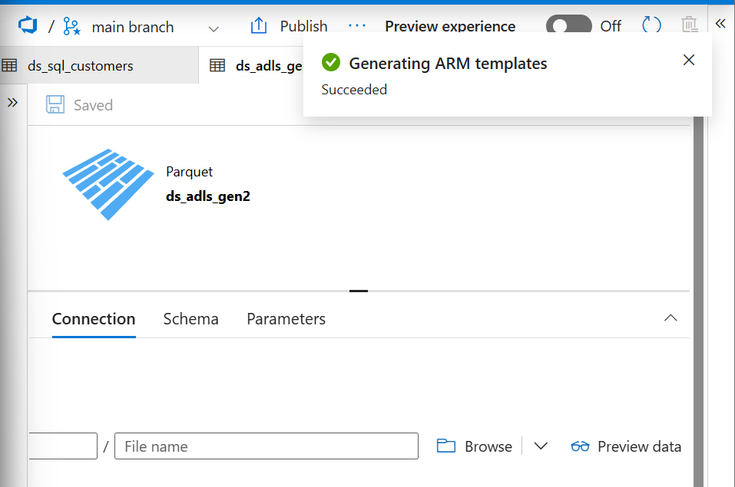

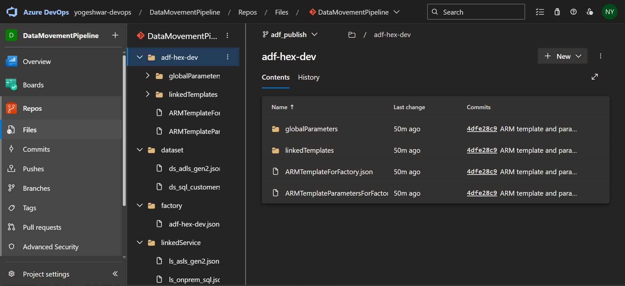

7. CI/CD Pipeline Setup
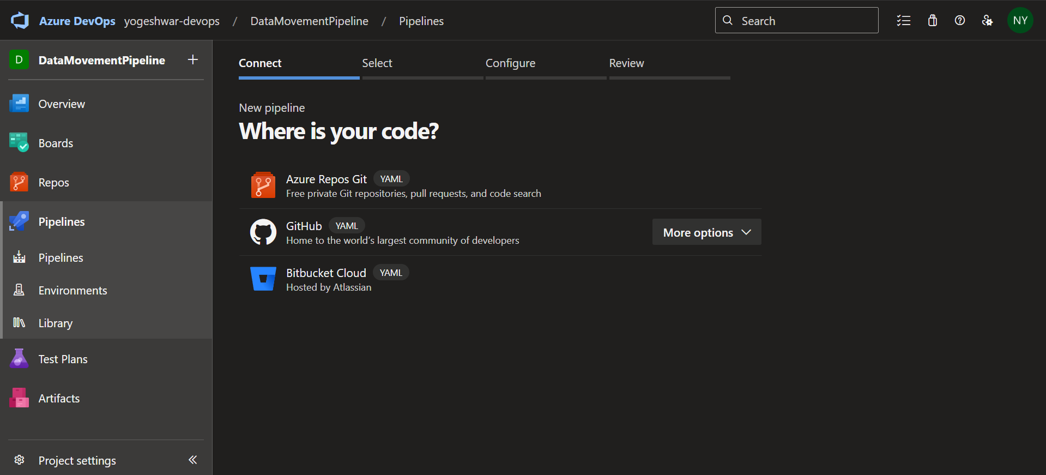
Azure DevOps service connection was created. CI/CD pipeline setup was initiated using the release pipeline approach. Deployment step is pending due to parallelism limitation in private DevOps organization (request sent to Microsoft).

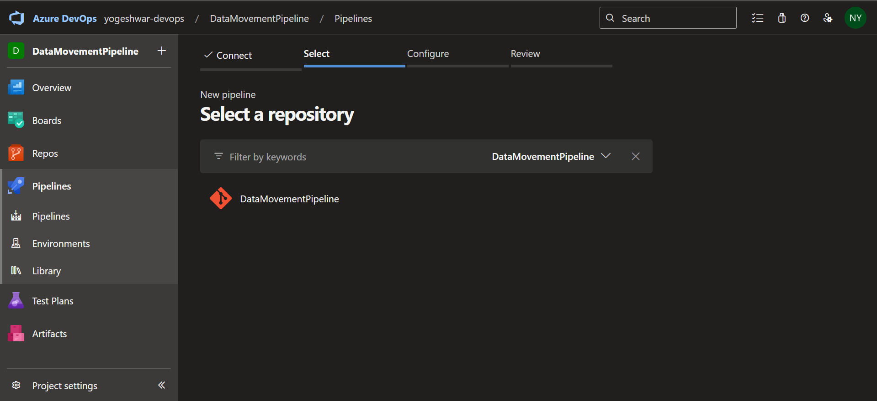

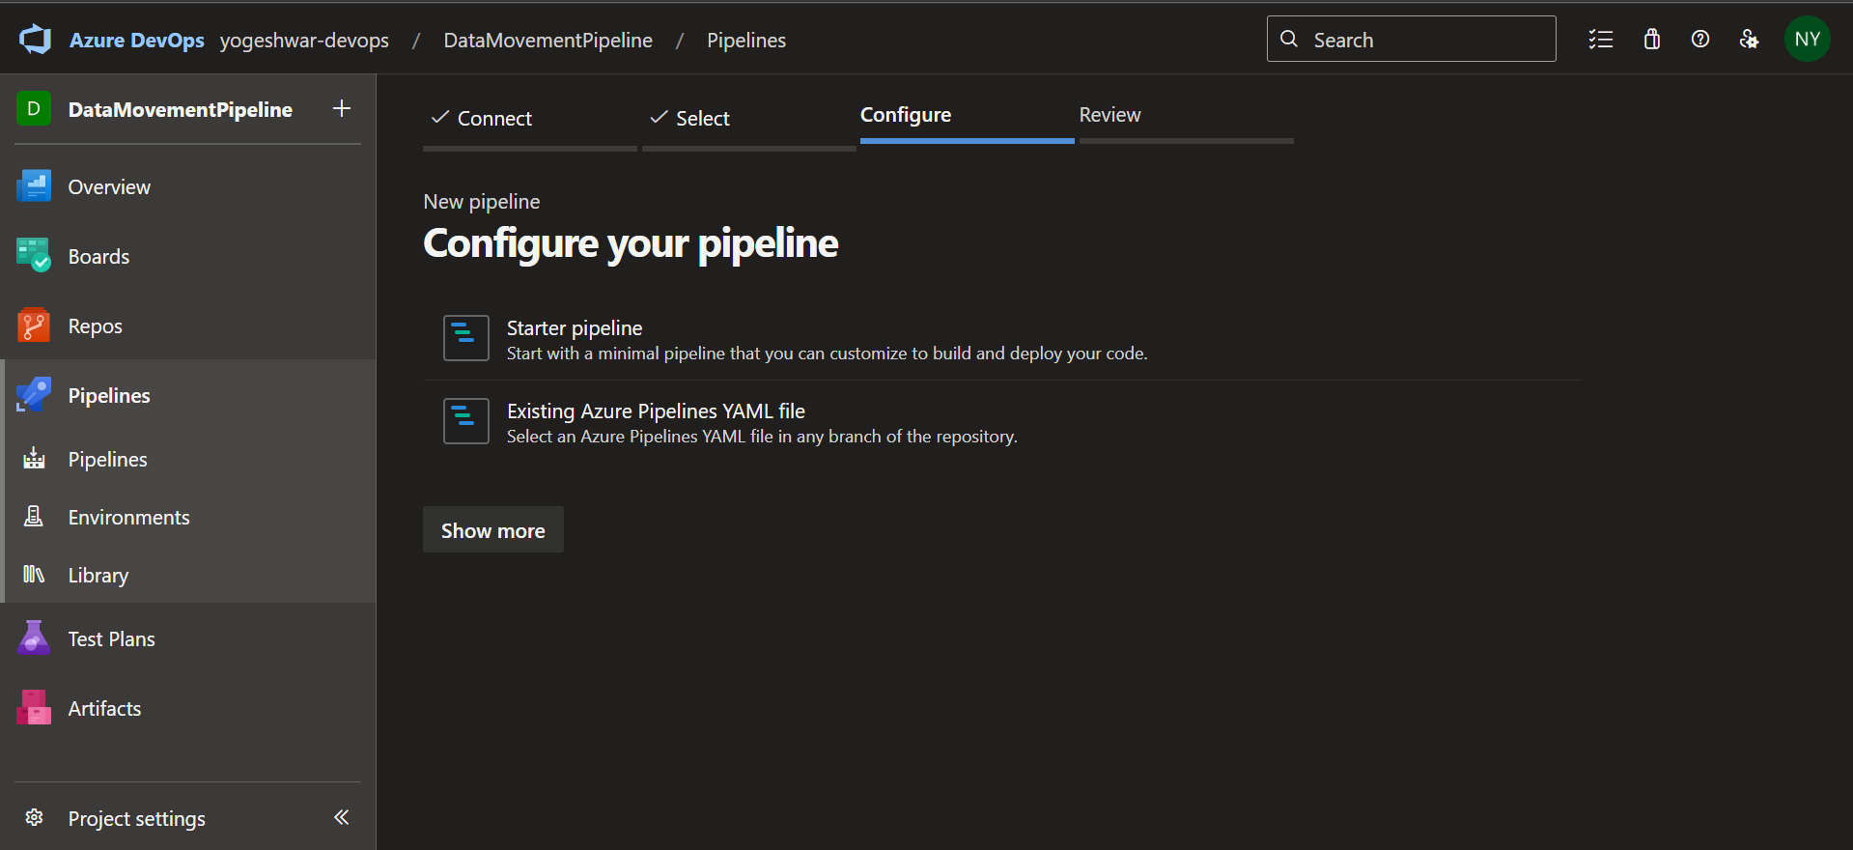

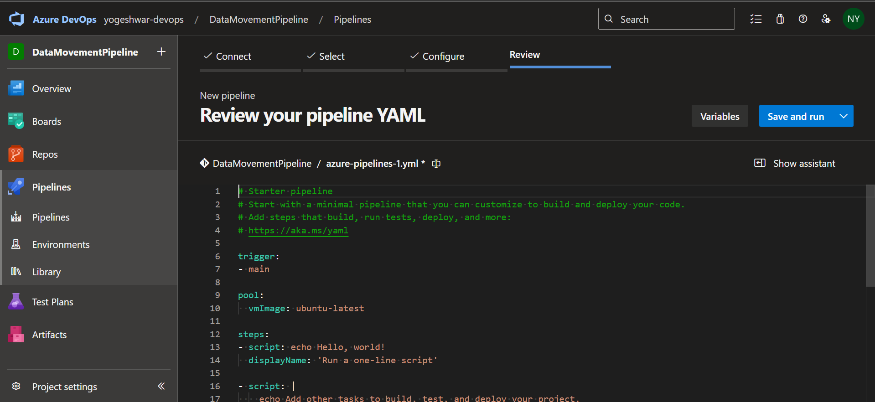

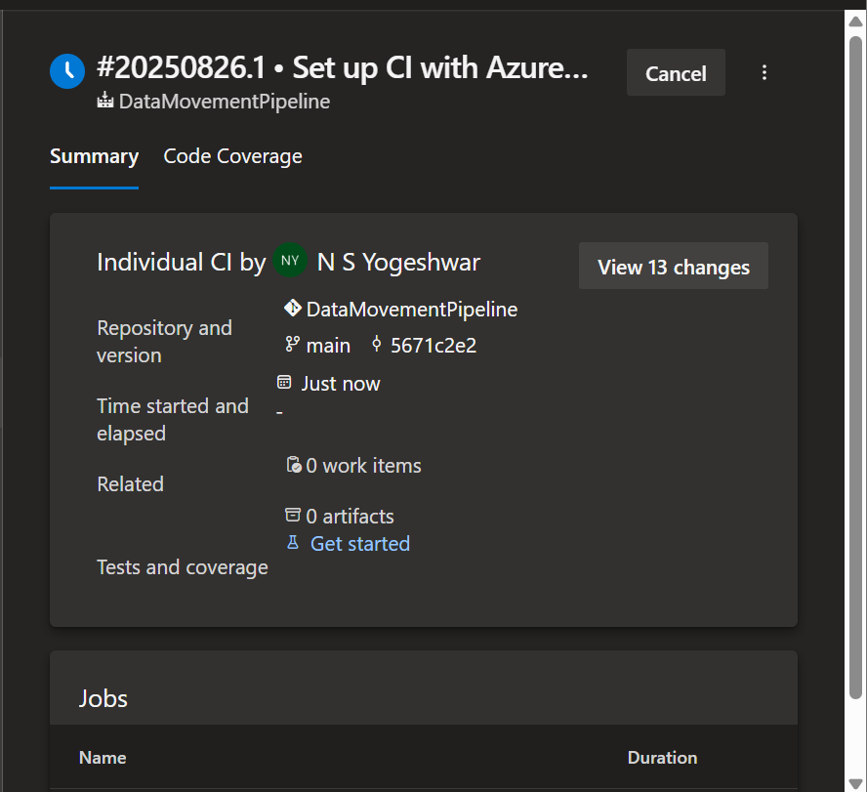

8. Conclusion & Learnings
- Successfully built a functional pipeline for data movement using ADF.
- Integrated pipeline with Azure DevOps for source control and CI/CD.
Verified successful data transfer and storage in Synapse.
- Learned how to set up cloud data pipelines, monitor runs, and link DevOps versioning.

